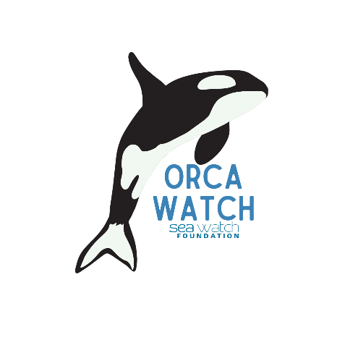
Orca Watch 2025 - Volunteer Watcher Scheme Application Form

24th May to 1st June

Dear Prospective Volunteer,
Thank you for expressing your interest in joining the Orca Watch Volunteer Watcher Scheme for Orca Watch 2025. We appreciate your commitment to this important initiative. To apply, kindly complete and submit the following form by the end of Monday, February 24th.

PERSONAL INFORMATION (BLOCK CAPITALS please):

Name

Email Address

Mobile Number

YES | NO
I confirm I have read the Terms & Conditions of the scheme.

AVAILABILITY:
Please indicate the dates and times you are planning to be at Orca Watch 2024.
Date | AM | PM | All Day
Saturday, May 24th
Sunday, May 25th
Monday, May 26th
Tuesday, May 27th
Wednesday, May 28th
Thursday, May 29th
Friday, May 30th
Saturday, June 31st
Sunday, June 1st

LOCATION DETAILS:
Where are you planning to be based during Orca Watch? (e.g., John O’ Groats, nearby areas, further afield). Please state the nearest village.

TRANSPORTATION:
YES | NO
Will you have access to your transport during Orca Watch?
YES | NO
If you have your transport, would you be willing to take others with you to a watch site?
Yes
WATCH PREFERENCES:
What type of watches are you interested in conducting?
Land-only
Land and ferry
Too early to say

EXPERIENCE:
YES | NO
Although no experience is necessary, it will help our planning to know if you have taken part before in timed watches for Sea Watch or any other organisation.
If yes, for which organisation(s)?
Sea Watch
WDC
ORCA
MARINELife
HWDT
Other(s) (please name)

Have you conducted watches from land, sea, or both?
Land
Sea
Both

Which of these species have you seen in the waters around the Orca Watch area?
Orca
White-beaked dolphin
Harbour porpoise
Atlantic white-sided dolphin
Bottlenose dolphin
Risso’s dolphin
Minke whale
Other (please specify)

CONNECTIONS:
YES | NO
Are there other people you know who may be applying to become Official Volunteers with whom you'd like to watch? If so, please state their names so we can try, where possible, to match you up.

CHILDREN AND FAMILY:
YES | NO
Are you registering with children?
If yes, please state their age(s) and any experience they have had watching for whales and dolphins.

ACCESSIBILITY AND DISABILITY INFORMATION
We value inclusivity and strive to make Orca Watch as accessible as possible. However, please note that some of the watch sites may have limited accessibility due to their natural settings. This may include short walks, uphill paths, steps, or stretches along beaches.
We assure you that accessibility considerations will not impact the success of your application. If you have any specific accessibility needs or concerns, please let us know in advance. We are committed to making reasonable adjustments to accommodate your requirements wherever possible.
☐ Please tick here if you require specific accessibility adjustments, and provide details below if applicable:

PRIVACY CONSENT:
YES | NO
Are you happy for your contact details to be shared with other Orca Watch Volunteer Watchers, so we can add you to group emails and WhatsApp groups?

Thank you for completing this form. Please email it to orcawatch@seawatchfoundation.org.uk with the subject line “Volunteer Scheme”.
We will acknowledge receipt of your application as soon as we can. We will contact you by the end of Friday, 7th March let you know whether your application has been successful. If you have been successful, we will also, at that time, ask you to pay the £27 registration fee. If your application isn't successful, don't worry! You can still come along and take part, join in watches, and enjoy all Orca Watch has to offer.
DATA SECURITY, STORAGE AND SHARING
We are committed to keeping the personal information you provide to us secure, and we will take reasonable precautions to protect your personal information from loss, misuse, or alteration.
The data that we hold will not be shared with any third parties for marketing purposes. We will not pass on the data we hold to any other organisation (unless required to under the law).
Your information is held in the strictest confidence. We use paper-based documentation and mainstream software packages which are kept up to date with all the latest updates and security patches. Access to the documentation and software is by restricted access and we use the most secure login options available to us.
To view our full privacy policy, go to https://www.seawatchfoundation.org.uk/privacy-policy/
We look forward to your participation in Orca Watch 2025!

