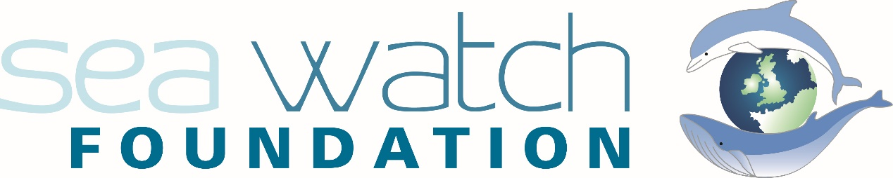
Sea Watch Foundation Cymru, Paragon House, Wellington Place, New Quay, Ceredigion, SA45 9NR
Tel: +44 (0) 749 875 0310
Web: www.seawatchfoundation.org.uk
Report your sightings (website): seawatchfoundation@gmail.co.uk
Report your sightings (APP): Sea Watcher (android) Sea Watcher (iOS)
Add events: simone.evans@seawatchfoundation.org.uk Submit data: nwdw@seawatchfoundation.org.uk

June 2024

Thank you for choosing to take part in National Whale and Dolphin Watch 2024

Last year 1490 sightings were reported, totalling 10 156 individual animals on record and we hope to surpass these numbers in 2024. We encourage all those getting involved in National Whale and Dolphin Watch 2024 to schedule events throughout the week and to engage with as many members of the public as possible! The more eyes we have looking at the sea, the better picture we are able to build.

Please report your sightings to us as soon as possible! We encourage all of our observers to use our free SeaWatcher App as the most efficient way to submit sightings to us however we are happy to receive sightings through the website, over email and over the phone! If you are conducting watches using watch-sheets, please send your effort and sightings data as soon as possible either through email or post.

We are committed to reducing our environmental footprint and therefore are trying to go as paperless as possible this year but we do understand that some things may need printing so if you need us to send you a hard copy of anything attached, please let us know and we can get that organised.

Our team is here to assist you throughout the event. Feel free to contact us for any questions or guidance and we will be happy to help!

Event Materials Included:

- Flyers/ Posters for advertising National Whale and Dolphin Watch in your area.
- A watch registration sheet to provide information on when/ where your watches will be.
- A "watch info sheet" for each of your planned watches. Completing this form after each watch (including the number of participants) helps us understand how many people were involved in National Whale and Dolphin Watch
We can’t run this fantastic event without you, so I hope the weathers is on your side and that you have exciting sightings and lots of fun! Thank you so much for your time and effort and have a great National Whale and Dolphin Watch 2024!
Sincerely,
The National Whale and Dolphin Watch Team
Simone Evans
Sightings Officer
Simone.evans@seawatchfoundation.org.uk

Claudia Afeltra
Communications Officer
claudia.afeltra@seawatchfoundation.org.uk

NWDW assistant
nwdw@seawatchfoundation.org.uk

National Whale and Dolphin Watch 2024
Watch Registration
Thank you for your interest in undertaking watches for National Whale and Dolphin Watch 2024. To finalise your watches, please complete and submit this form back to the main organisers.
Full name (BLOCK CAPITALS please): ________________________________________________
Email Address: ___________________________________________________________________
Mobile Number: _________________________
Home Address:
___________________________________________________________________________________

- Please indicate the dates and times you are planning to organise watches at National Whale and Dolphin Watch 2024.
 | LAND | BOAT | TIME (start/end)
Friday 26th July
Saturday 27th July
Sunday 28th July
Monday 29th July
Tuesday 30th July
Wednesday 31st July
Thursday 1st Aug
Thursday 2nd Aug
Friday 3rd Aug
Saturday 4th Aug

- Where are you planning to be based during National Whale and Dolphin Watch? E.g. Strathy Point, Caithness. Please state location and county. (This information will help us plan the watches in your area). If you conduct multiple watches during the event, please specify your base if different for every watch.
________________________________________________________________
________________________________________________________________

- What type of watch, vessel-based or land-based, are you interested in conducting?
Land
Vessel
Both

- Will these watches be private or Public?

Private
Public

- Although no experience is necessary, it will help our planning to know if you have taken part before in timed watches for Sea Watch or any other organisation.
Yes
No

If yes, for which organisation(s)?
Sea Watch ☐ WDC ☐ ORCA ☐ MARINELife ☐ HWDT ☐
Other(s): ___________________________________________________________________

Have you conducted watches from land, sea or both?
Land
Sea
Both

What species have you seen?
Orca |  | White-beaked dolphin
Harbour porpoise |  | Atlantic white-sided dolphin
Bottlenose dolphin |  | Risso’s dolphin
Minke whale |  | Common dolphin
Humpback whale |  | Fin whale
Sperm whale |  | Pilot whale
Others (list their names)

- Would you be interested in joining our online regional marine mammal training days? They’ll train you on how to use our recording forms and on how to monitor cetaceans in the wild. Training days will be announced on our social media platforms as soon as dates of all watches are finalized on our website.
Yes No

- Are you happy for your contact details to be added to our contact list, so we can be contacted for future NWDW events?
Yes No

Thank you for completing this form. Please email it to
nwdw@seawatchfoundation.org.uk with the subject line “Name Surname – Watches Registration”
We will acknowledge receipt of your application as soon as we can.

Data security, storage and sharing
We are committed to keeping the personal information you provide to us secure and we will take reasonable precautions to protect your personal information from loss, misuse or alteration.

The data that we hold will not be shared with any third parties for marketing purposes. We will not pass on the data we hold to any other organisation (unless required to under the law).
Your information is held in the strictest confidence. We use paper-based documentation and mainstream software packages which are kept up to date with all the latest updates and security patches. Access to the documentation and software is by restricted access and we use the most secure login options available to us.

To view our full privacy policy, go to https://www.seawatchfoundation.org.uk/privacy-policy/

